**Course name: Human Computer Interaction**

**Assignment no.: 2**

**Title: Improving Lives with HCI Products**

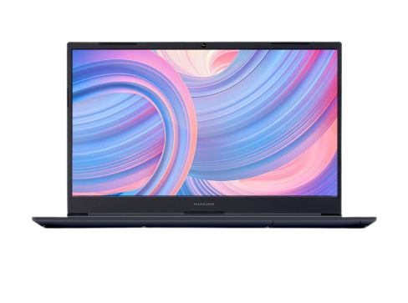

**Subtopic 1. Value and benefit**

The product or service that I have used the most is undoubtedly my laptop. It is an essential item for young university students, and I cannot imagine going a single day without using it. From writing this essay to listening to music, watching movies or dramas, and playing games, there are countless things that I can do with my laptop. It is also possible to install various apps on my laptop, just like on a smartphone, allowing me to enjoy the features of those apps. For example, if I install a social media app, I can interact with others through social media. When I consider the services that a single app provides, the ability to do various interactions through my laptop, with over a million apps available, makes it an incredibly valuable item.

My laptop has been an indispensable tool for me. As a student, I have used it for taking notes during lectures, completing assignments, and doing research. Outside of academics, it has been a source of entertainment, allowing me to watch movies and dramas, listen to music, and play games. Moreover, the ability to install various apps on my laptop has expanded its functionality even further. I can communicate with my friends and family, shop online, and access a wide range of information and resources from around the world.

In addition, my laptop has been a crucial device for my work. As a freelance writer, I use it to write articles, communicate with clients, and manage my business. The portability of my laptop has also been a significant advantage, allowing me to work from anywhere, whether it be at home, a coffee shop, or on the go.

Every person has their own needs and desires. Sometimes, what other people need can become what we need, or what a lot of people want can become a big necessity and commercial benefit. However, not all products will improve people's lives. As different products are developed, some people may become lazier and their lives may worsen in other ways.

To sum up, my laptop has been really helpful for me in school, for fun things, and for my job. It can do a lot of things, and I can take it with me wherever I go. But it's important to remember that not everything we buy will make our lives better, and we need to be careful not to use them in ways that make things worse for us.

**Subtopic 2. Your ideas**

I have come up with a few new HCI product ideas related to home and human life. As a student, I sometimes feel lazy to wash my hair in the morning. Therefore, it would be convenient to have a machine that can wrap and dry my hair like a perm machine in a hair salon. The target groups for this product are people with mobility issues and those who are lazy. With this product, people who cannot move freely can become clean, and those who are busy and lazy can save time. For me, the value of this product is that it saves time. I can sleep a little more in the morning and start my day feeling refreshed. The inputs for this machine are electricity, water, shampoo, and warm air, and the output is clean and styled hair as desired.

Secondly, it would be great to have a machine that separates and recycles waste. This is directly related to environmental issues. People would make a habit of separating and disposing of waste if there were such a machine. The target group for this product is everyone in the world. The main idea is to separate waste based on the light transmittance of each type of garbage. Through waste separation, economic and environmental benefits can be gained. This product can provide convenience, comfort, health, and efficiency. The inputs for this machine are a light and classification system, and the output would be the sorted waste.

These two product ideas could make our lives better. One is a hair machine that wraps and dries your hair, like in a salon. It can save time for people who can't move much or who don't want to wash their hair in the morning. The other idea is a machine that separates and recycles waste. It can help us take care of the environment by sorting trash based on how much light can pass through it. We need to keep coming up with new ideas to solve problems in our lives. We can use new technologies to make things easier and better, and also help our planet stay healthy.